**Run a Static Website on Containers**

PRACTICAL:2

**Steps:**

1. Go to [Azure Portal](https://portal.azure.com/)
2. In the search bar, type **Storage Accounts** and click **+ Create**
3. Under **Basics**:
   * **Subscription**: Your Azure subscription
   * **Resource Group**: Create/select a resource group AZ900-Storage
   * **Storage account name**: storage443
   * **Region**: Central India
   * **Performance**: Select **Premium**
   * **Redundancy**: Select **Locally-redundant storage (LRS)**
4. Click **Review + Create**, then **Create**
5. Wait for deployment to complete.

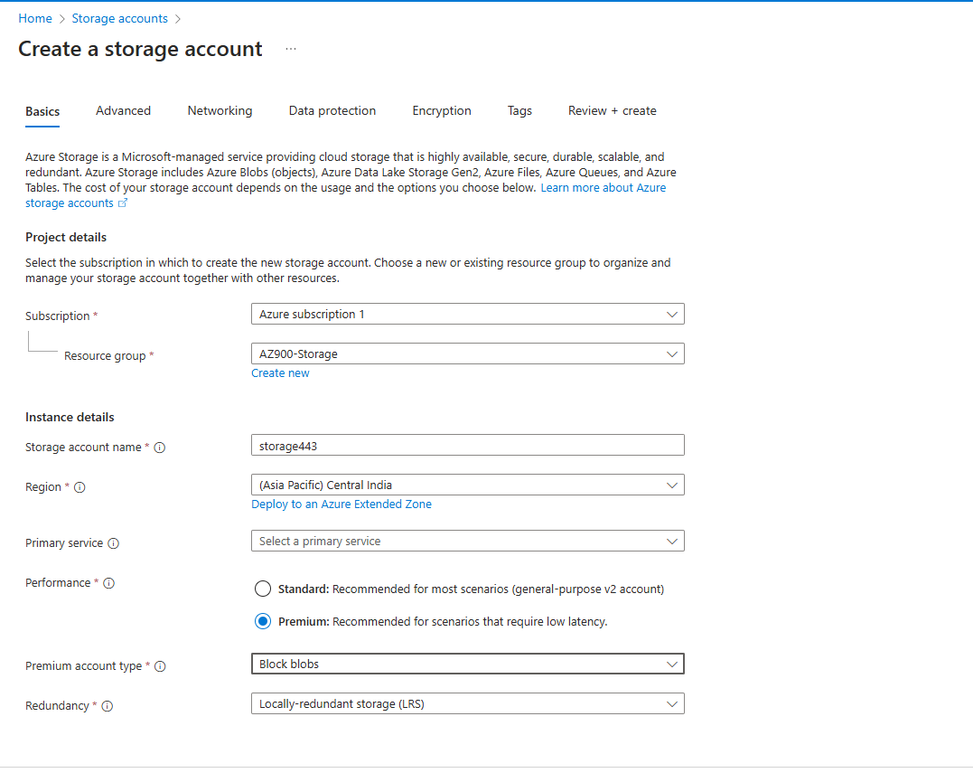

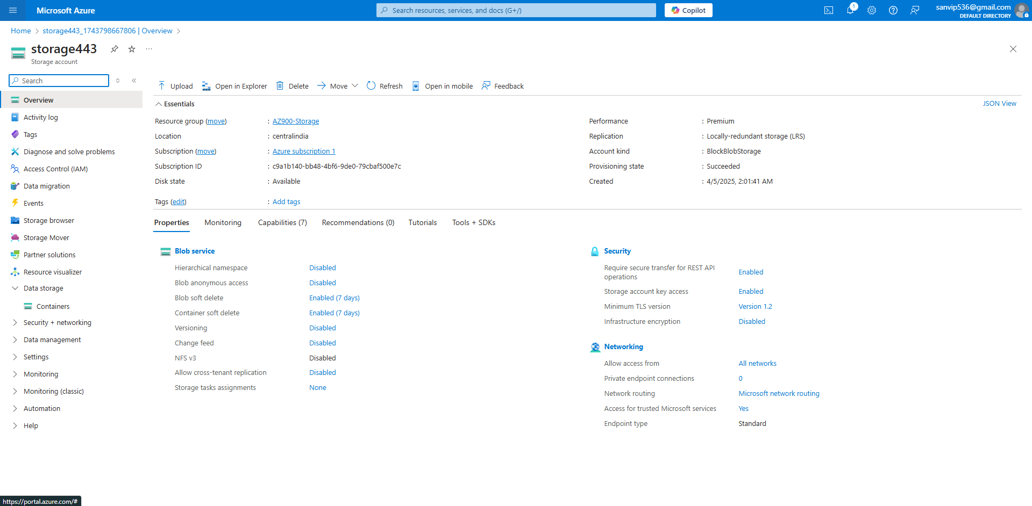

2. Create a Blob Container and Upload 5 Images.

**Steps:**

1. Go to **Storage Accounts** > Select storage443
2. Under **Data Storage**, click **Containers**
3. Click **+ Container**, enter **Name** as images, and click **Create**
4. Open the images container
5. Click **Upload**, select **5 images** from your local machine, and click **Upload**

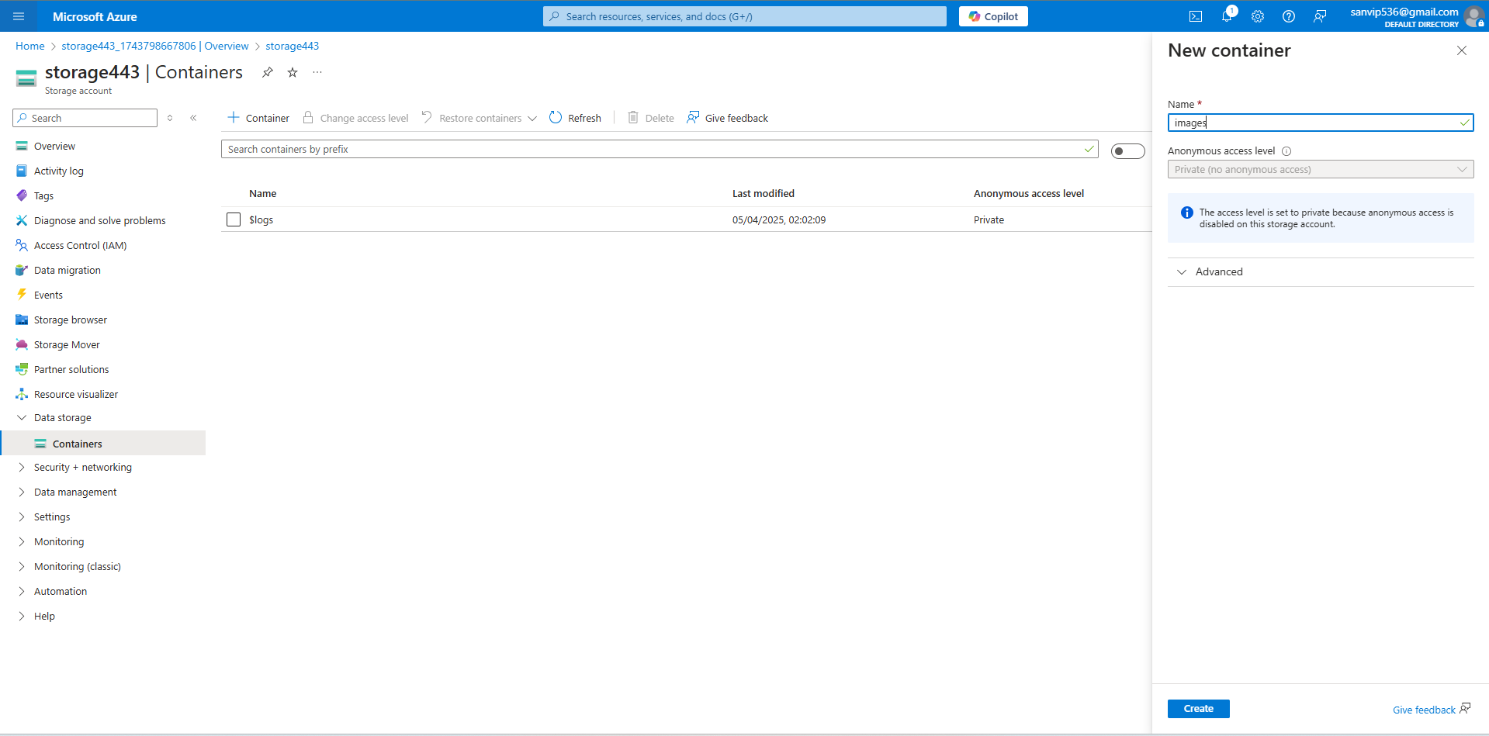

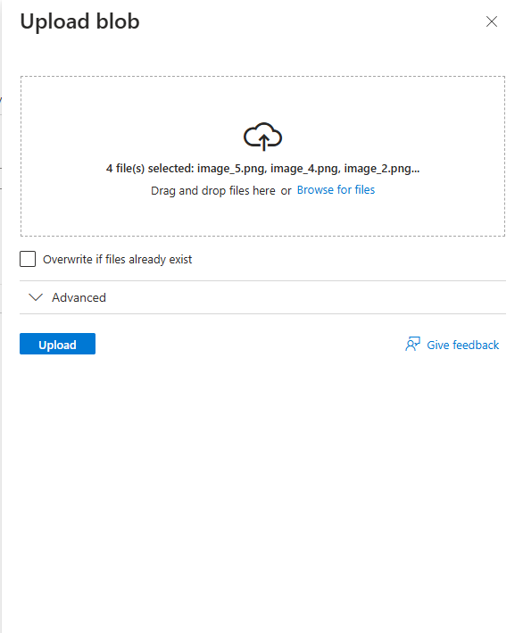

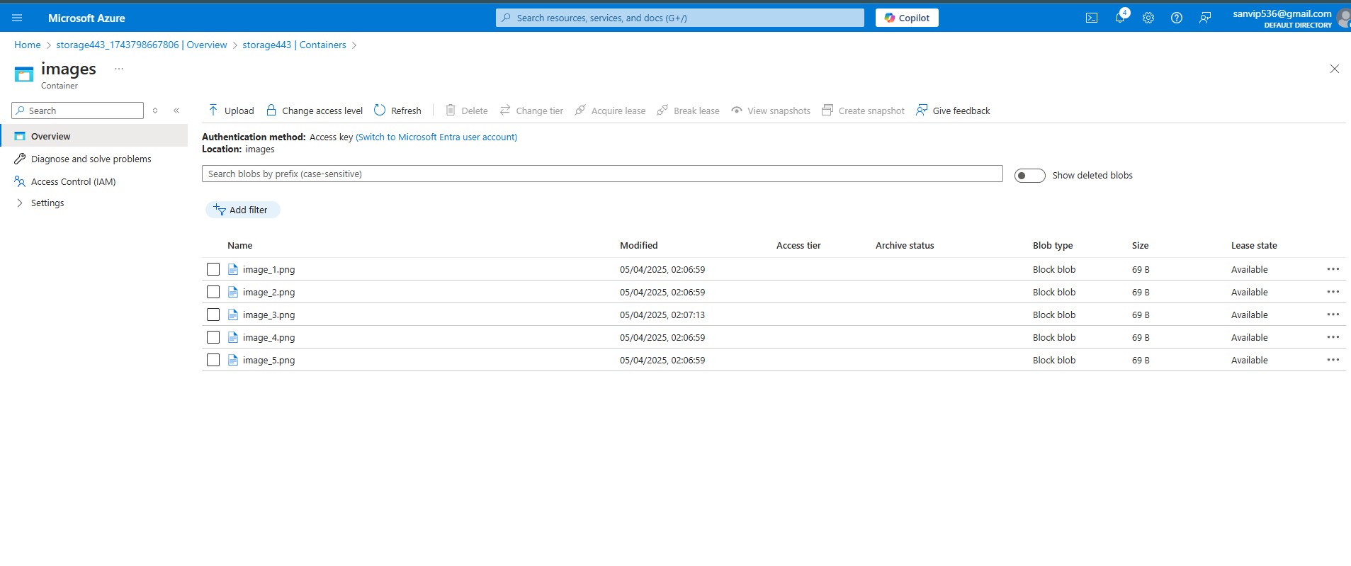

**3. Calculate Cost Using Azure Pricing Calculator**

**Steps:**

1. **Go to** [**Azure Pricing Calculator**](https://azure.microsoft.com/en-us/pricing/calculator/)
2. **Click Storage Accounts**
3. **Configure as follows:**
   * **Region: Central India**
   * **Type: Block Blob Storage**
   * **Performance Tier: Premium**
   * **Redundancy: LRS**
   * **Keep all other parameters as default**
4. **The estimated cost will be displayed based on the selected configuration.**

